Access Ticket Guide

Seating Options:

Accessible Viewing Platform
- Spaces are limited and subject to availability on a first come first serve basis.
- There are 6 wheelchair spaces and 6 free of charge companion seats per concert on the Accessible Platform.

Step Free Access
- Access requirements can be accommodated on the flat areas of the auditorium in Blocks B, C & D, and the front row of Block A.
- Spaces are limited, subject to availability and booked in advance on a first come first served basis. (Please Note: Your view may be restricted as guests are not prohibited from standing in front of their seats).
- Pairs of seats have been designated as Wheelchair or Ambulant Accessible Seating on our seat map. These seats are designated for those who require step-free access, aisle access, and are in closer proximity to the stage, exit and toilets.
- These seats include a free of charge Personal Assistant ticket, with the price of 1 ticket split across these 2 tickets.

Other Seating
- Blocks A and AUC are in the tiered section of the venue.
- These seats do not have step free access with a total of 34 steps from Block A Row A to Block AUC Row MM.
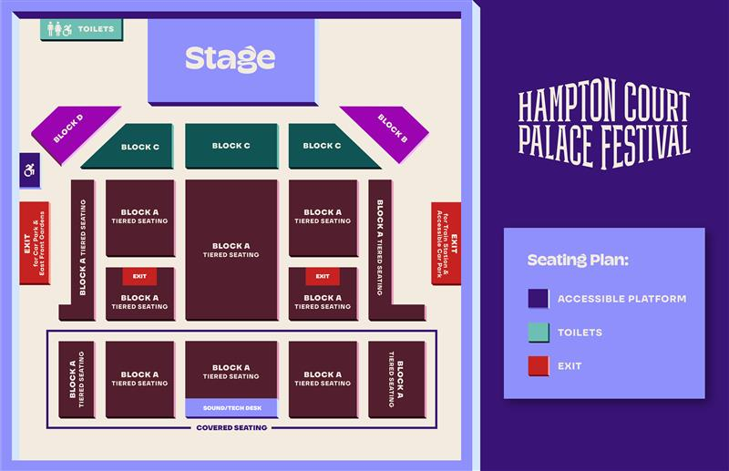

Personal Assistant Tickets
We offer Personal Assistant tickets for guests that may require additional assistance whilst at Hampton Court Palace Festival. Please see a step-by-step guide on how to book these tickets below.
Example photos shown below are for the 10cc show on 17th June 2025. Please note prices between concerts will vary.

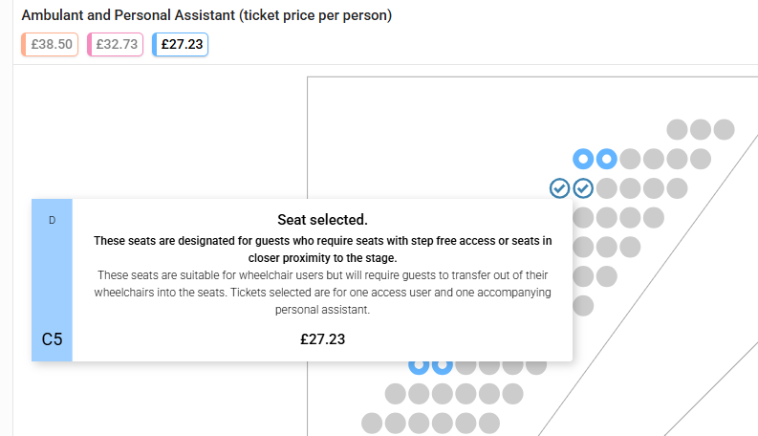
Step one: Select your Seats
If you are using the seat picker…
- Seat pairs have been designated in Blocks B, C, D, and the front row of Block A.
- These seats include a free of charge Personal Assistant ticket.
- The ticket price of 1 ticket has been split across the 2.

Wheelchair Viewing Platform
- Scroll down to the Wheelchair Accessible and Personal Assistant tab.
- Select your ticket type and change the quantity to 2.
- Tickets selected are for one access user and one accompanying personal assistant.

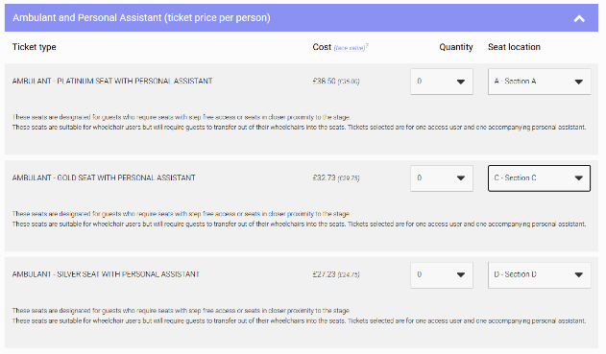
If you are using the select the best seats option…
- Scroll down to the Ambulant and Personal Assistant or Wheelchair Accessible and Personal Assistant tab.
- Select your ticket type and change the quantity to 2.
- Tickets selected are for one access user and one accompanying personal assistant.

If there is not a ticket option available for your preferred concert, this may be because this option is currently sold out. Please contact us directly where our team will be able to assist you with your booking, subject to availability: https://help.hamptoncourtpalacefestival.com/hc/en-us/requests/new
Step 2: Purchasing your tickets
Continue to checkout to purchase your tickets.
Remember to add your parking pass to your order if you are travelling by car. See our step-by-step guide on how to book Blue Badge Parking HERE.

Step 3: Upload your documentation
You will need to submit your supporting documentation when prompted on the checkout page.
Examples of relevant documentation to support your Personal Assistant request include:
- DLA (Disability Living Allowance)
- PIP (Personal Independence Payment)
- Evidence of registered severely sight impaired (blind)
- CredAbility Access Card (with +1 icon)
- Copy of Attendance Allowance letter
- Recognised Assistance Dog ID card
- Any other relevant documentation
All documents provided must show your full name and be dated from no older than 2022.
If you have not heard from See Tickets after submitting your documentation, please do come along to the event with your tickets as these will be valid and we will be able to assist you further with any queries.

Step 4: Receiving Your Tickets
You will receive a confirmation email once you have made your booking, and your tickets will be issued via email closer to the event.

For any ticketing queries please contact See Tickets: https://hcpfestival.seetickets.com/customerservice
For any queries about the event, please reach out to our team here: https://help.hamptoncourtpalacefestival.com/hc/en-us/requests/new

