Getting Here Guide

Festival Address
Hampton Court Palace
East Molesey
Surrey
KT8 9AU

Parking
Hampton Court Palace is situated south-west of Central London and is close to Kingston-upon-Thames. It is 20 minutes from Junctions 15, 12 and 10 of the M25.
If you would like to drive to the festival, you will be required to pay for festival parking. We strongly advise that you purchase your parking pass at the time of booking your concert tickets. Please see map above for the location of our general and accessible carparks
Parking requests will close online at midday on the day of your concert. Book before midday on the day of the concert to save.
We offer free of charge Blue Badge parking which must be booked in advance of your visit as blue badge spaces are limited. Please see below a step-by-step guide on how to book your Blue Badge Parking.
Please note parking is subject to availability and allocated on a first-come first-served basis. Pre-booking is strongly advised.

Train
Hampton Court Palace is situated only a few minutes walk from Hampton Court Station, which is on a direct line to and from London Waterloo. There are 2 direct trains per hour from London Waterloo, which take 40 minutes from central London. Visit southwesternrailway.com to book your ticket or call 0345 6000 650.
Hampton Court station is in fare zone 6, so you can get there using a London Travelcard, an Oyster card, or contactless.

Bus
Four bus lines operate in the area, with the 111 operating 24 hours a day. To see a TfL map take a look HERE
Towards Kingston:
- 111 – Bus stop Hampton Court Palace (stop C), running every 14 minutes, 24 hours a day. Final stop Cromwell Road Bus Station, Kingston
- 216 – Bus stop Hampton Court Palace (stop C), running every 30 minutes until 00:07. Final stop Cromwell Road Bus Station, Kingston
- 411 – Bus stop Hampton Court Palace (stop C), running every 60 minutes until 23:44. Final stop Cromwell Road Bus Station, Kingston
Towards Richmond:
- R68 – Bus stop Hampton Court Green (stop E), running every 20 minutes until 00:10. Final stop Kew Retail Park

Taxi
The only drop off and pick up point for taxis is Home Park – KT8 9AU.
Please see the numbers for some local taxi companies, that provide minicab services and have been informed of high demand:
- Angel Cars West Molesey: 020 8941 4151
- Bats Cabs Hampton: 020 8893 8080
- Kingston Minicabs Cars: 020 8390 3000
- Molesey Taxis Capital Cars: 019 3230 0311
- My Walton Taxis (King Cars): 0193230 4304
- ZedCarz Minicab: 020 8330 3300
Uber, Bolt and Lyft also operate in the area.

Boat
A boat service from Turks Pier, Kingston-upon-Thames (short walk from Kingston station) to Hampton Court Palace takes 30 minutes. See the Turks Thames Cruises website HERE for all up-to-date details.

How to book Blue Badge Parking

Once you have selected your tickets, remember to add your parking pass if you are arriving by car.
Parking must be booked in advance of your visit as Blue Badge spaces are limited.
Parking requests will close on midday on the day of your concert.
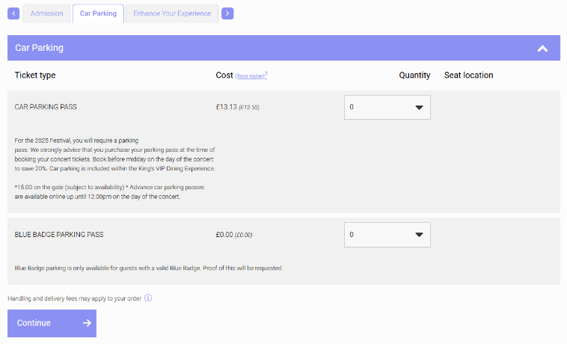

Step 1: Select parking
Change the Blue Badge Parking Pass quantity to how accommodate the number of spaces you require.

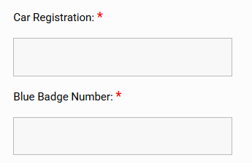

Step 2: Checkout
Continue to checkout where you will need to input your vehicle registration and Blue Badge Number.

Step 3: Confirmation email
Your parking pass will be sent to you via email along with your concert tickets.

Step 4: Arrival on the day
Present your parking pass to be scanned as you enter through the West Front Gates (Location: https://w3w.co/grant.purely.sector). You will also need to present your Blue Badge upon arrival at the event.

