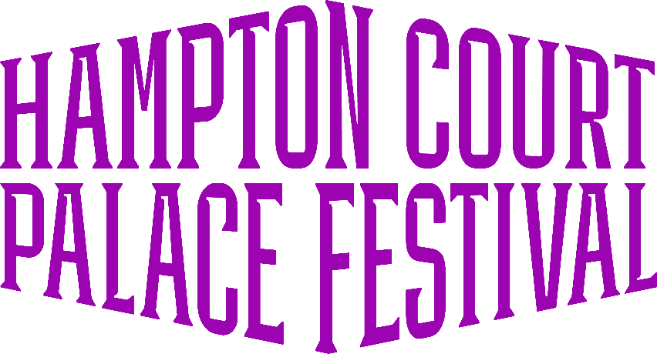

Welcome!
Taking place in the stunning Tudor Courtyard of Henry VIII's majestic Palace, the Festival provides world-class acts across 2 weeks in June. Enjoy the unique opportunity to see incredible performances within the intimate setting of Base Court set against the backdrop of Tudor history.

Contents
Contact Us 1
Ticketing 2
Site Description 2
Getting Here 2
Accessible Map 3
Level Access 3
Accessible Facilities 3
Sound and Lighting 3
Food and Drink 4
Assistance Dogs 4

Contact Us
Event Organiser Email: festivaltickets@img.com
Ticketing Contact: https://help.ticketmaster.co.uk/hc/en-us
Event Organiser Phone: 020 8233 5400
Event Information: https://help.hamptoncourtpalacefestival.com/hc/en-us
Accessibility Information: https://help.hamptoncourtpalacefestival.com/hc/en-us/sections/4978037936925-Accessibility

Ticketing
Free of charge tickets will be provided for Personal Assistants who require additional assistance.
These tickets can be purchased online via our website: https://hamptoncourtpalacefestival.com/tickets/

Site Description
Hampton Court Palace is an historic building and, therefore, has uneven surfaces.
The show is in a seated auditorium. Guests can stand during the show if they would prefer however we do advise guests to be mindful of those around them. Blocks A and AUC are in the tiered section of the venue with a total of 34 steps from Block A Row A to Block AUC Row MM
The ground on the East Front Gardens is a mixture of gravel and grass. Inside the palace itself (which includes the Auditorium and Clock Court bar) the flooring is a mixture of flagstones and cobblestones.
To see a photo gallery of terrain, seating, and facilities please take a look HERE

Getting Here
Address:
Hampton Court Palace
East Molesey
Surrey
KT8 9AU

Hampton Court Palace Festival is accessible via bus, train, car, and boat. Blue Badge Parking is available.

Please Visit our Getting Here Guide for more information

Accessible Map
Once our 2026 event map has been released, we will have a version highlighting accessible facilities linked here. Check back soon!

Step-Free Access
There is step-free access from the Blue Badge car park to the auditorium.
Blocks B, C, D, and the Accessible Viewing Platform have step free access. Blocks A and AUC are in the tiered section of the venue. These seats do not have step free access with a total of 34 steps from Block A Row A to Block AUC Row MM.
From the access car park, it is approximately a 5 to 10 minute walk on hard standing to the East Front Gardens, where guests can enjoy pre-concert drinks and picnics on the lawn.
Alternatively, you can head from the car park straight to the auditorium, which is a 3-5 minute walk from the car park on hard standing.

Accessible Facilities
- Accessible Viewing Platform with six wheelchair spaces and six companion seats per concert.
- Free of charge Personal Assistant tickets
- Free of charge Blue Badge Parking at the West Front entrance.
- Hearing Loop at the West Front Ticket Office
- Accessible toilets around the event.
- Wheelchairs are available to hire, subject to availability, through Hampton Court Palace (https://www.hrp.org.uk/hampton-court-palace/visit/accessibility/#gs.5sxzdv)
- Wheelchair users who book a non-dedicated wheelchair space may be asked to leave their wheelchairs outside the Palace Courtyard.
- Large Print Menus at our food traders on the East Front.
- If you require a BSL interpreter for any of the shows, please do contact our customer service team and they will be able to assist you. - Please note that we require a 4 week notice to book this in.

Sound and Lighting
Some parts of the venue have low lighting.

Food and Drink
We aim to cater for as many people as possible to ensure everyone is able to enjoy delicious food during at Hampton Court Palace Festival
Please do have a chat with any of our vendors about the ingredients in their dishes. They will always be happy to help with any questions.

Assistance Dogs
Hampton Court Palace Festival is committed to making sure the event is as inclusive and accessible to all and we understand that some customers will rely on an assistance dog to attend our events. Hampton Court Palace Festival can be crowded and at times loud, creating an unpleasant environment for animals. For these reasons, we do not permit our customers to bring non assistance animals with them.
Hampton Court Palace Festival reserves the right to turn away dogs at the gate who do not comply with Assistance Dogs UK guidelines surrounding assistance dogs.
In order to ensure the smoothest entry possible, we would ask customers to contact our customer service team so that they can help facilitate your entry at the festival and provided necessary information regarding the venue.
Please contact our team under Accessibility Information here: https://help.hamptoncourtpalacefestival.com/hc/en-us/requests/new

